**PES-VB Manual**

Step -1

Run Installed Software

It will ask for product key

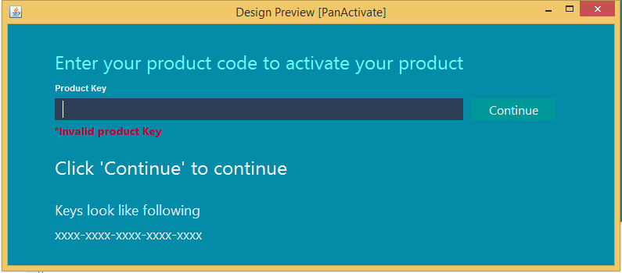

Enter valid product Key

Or continue for enjoy free 7 days Trail period

Step -2

Enter User Registration details

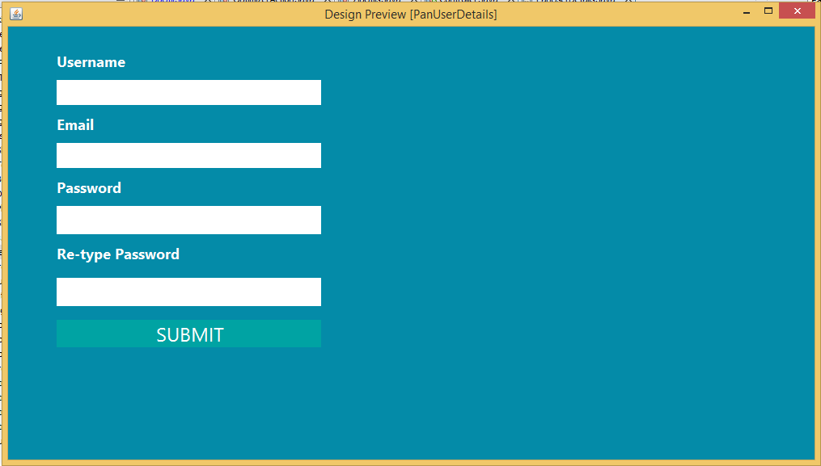

Wait till its processing and setting up connection for you

Step -3

Enter Login details and evaluate through competition and match

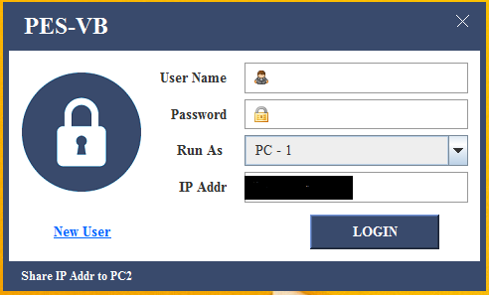

Want to connect different machine to one machine

Run the application select PC-2 from dropdown Enter Remote machine IP address and login details of that machine

As shown below in fig..

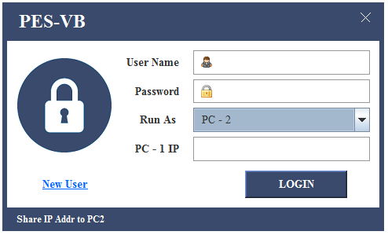

Step -4

After Successful login competition dashboard will be displayed which show competition list

Want to create new competition click on **New** button a dialog will appear as shown in fig

Enter competition details and click save competition will be created

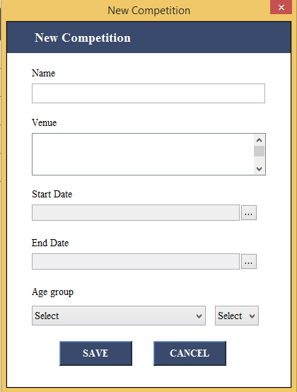

To View Matches in competition Click on View

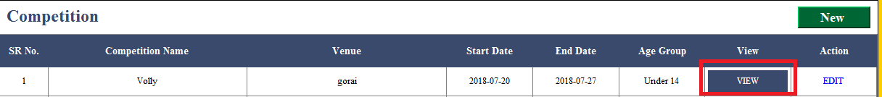

Competition match list will be shown to you as shown in fig.. below

To view match details ,team details,player details navigate through tab

For Matches

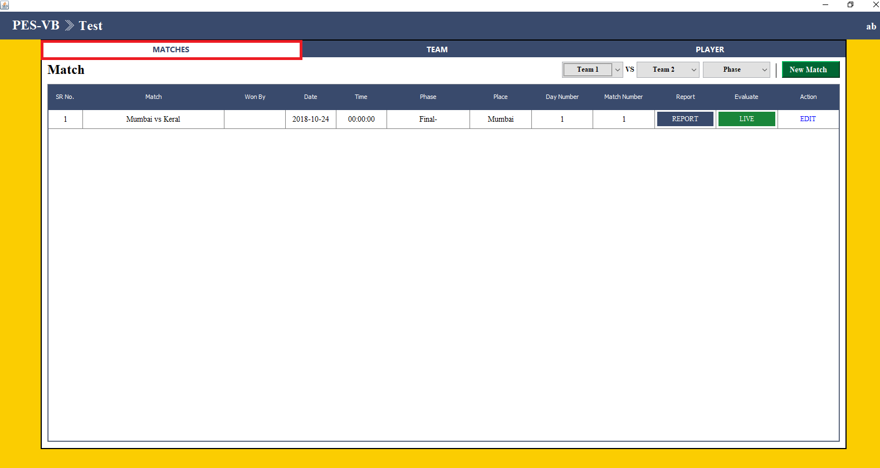

To schedule matches click on new match dialog will appear as shown in below fig

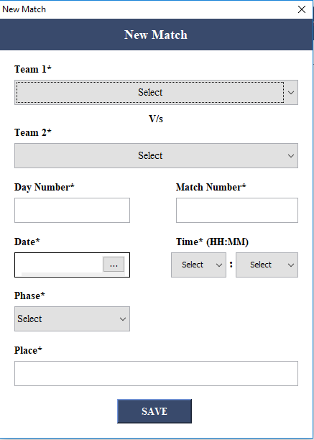

Select teams select date and schedule match and save

To edit match click edit and then do changes and update

To view teams

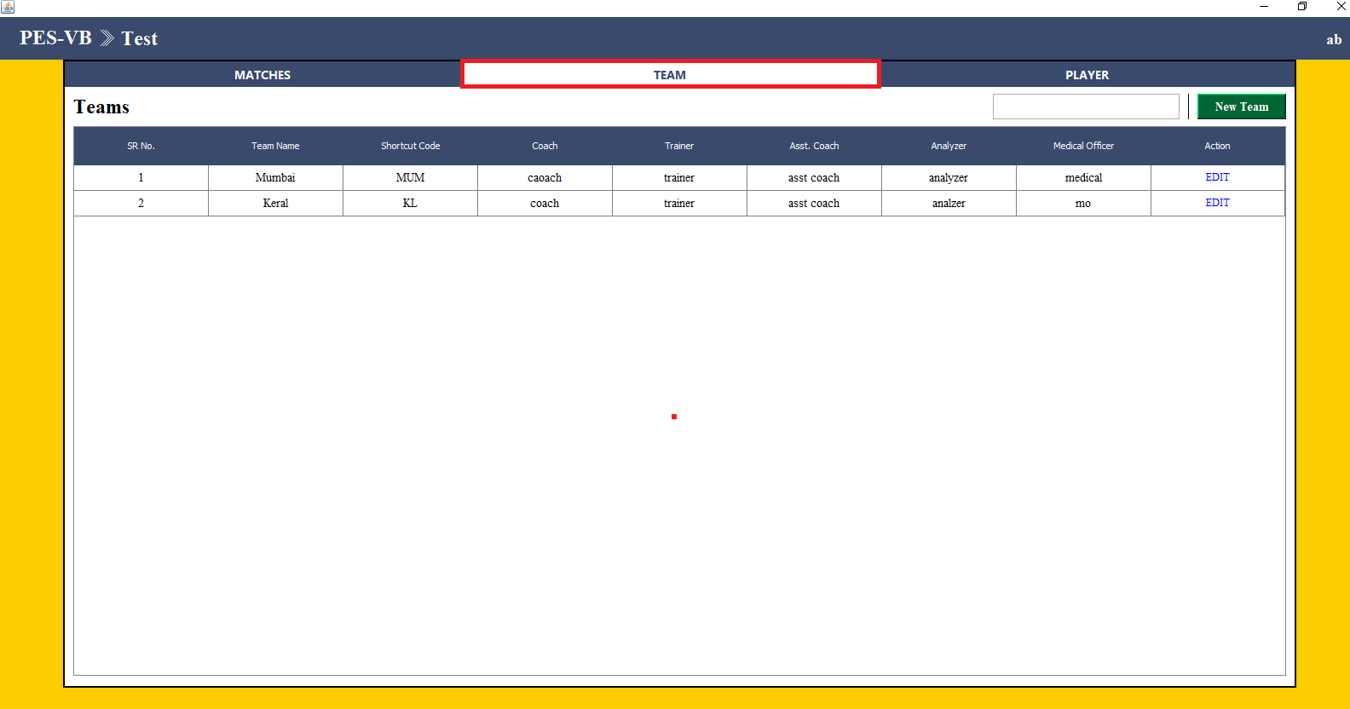

To add new Team click on New Team

Dialog will appear as shown fill team details and save to add player above 7 click New Player to remove row which is added click on (-)

Click save finally to add team

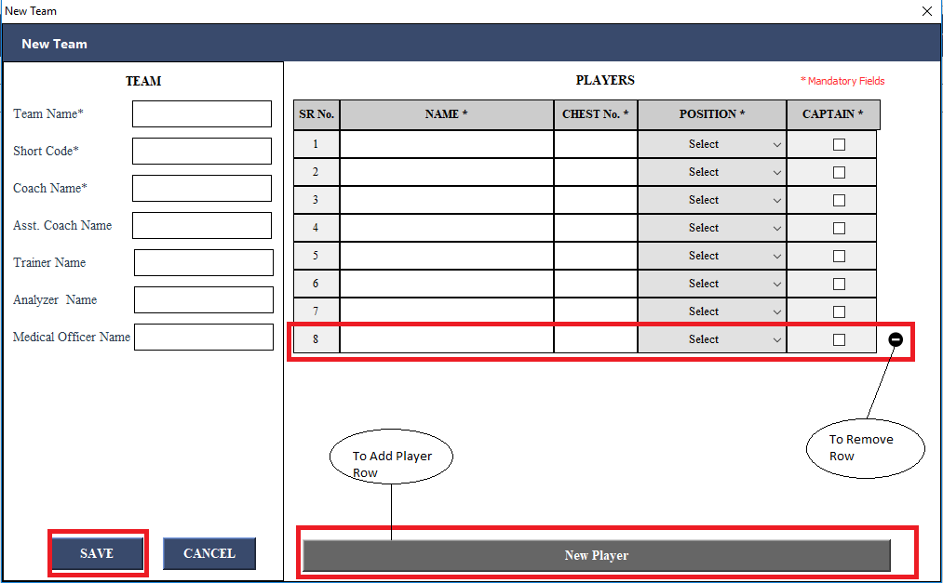

To edit team details click edit and do changes and click save to reflect changes

To view players

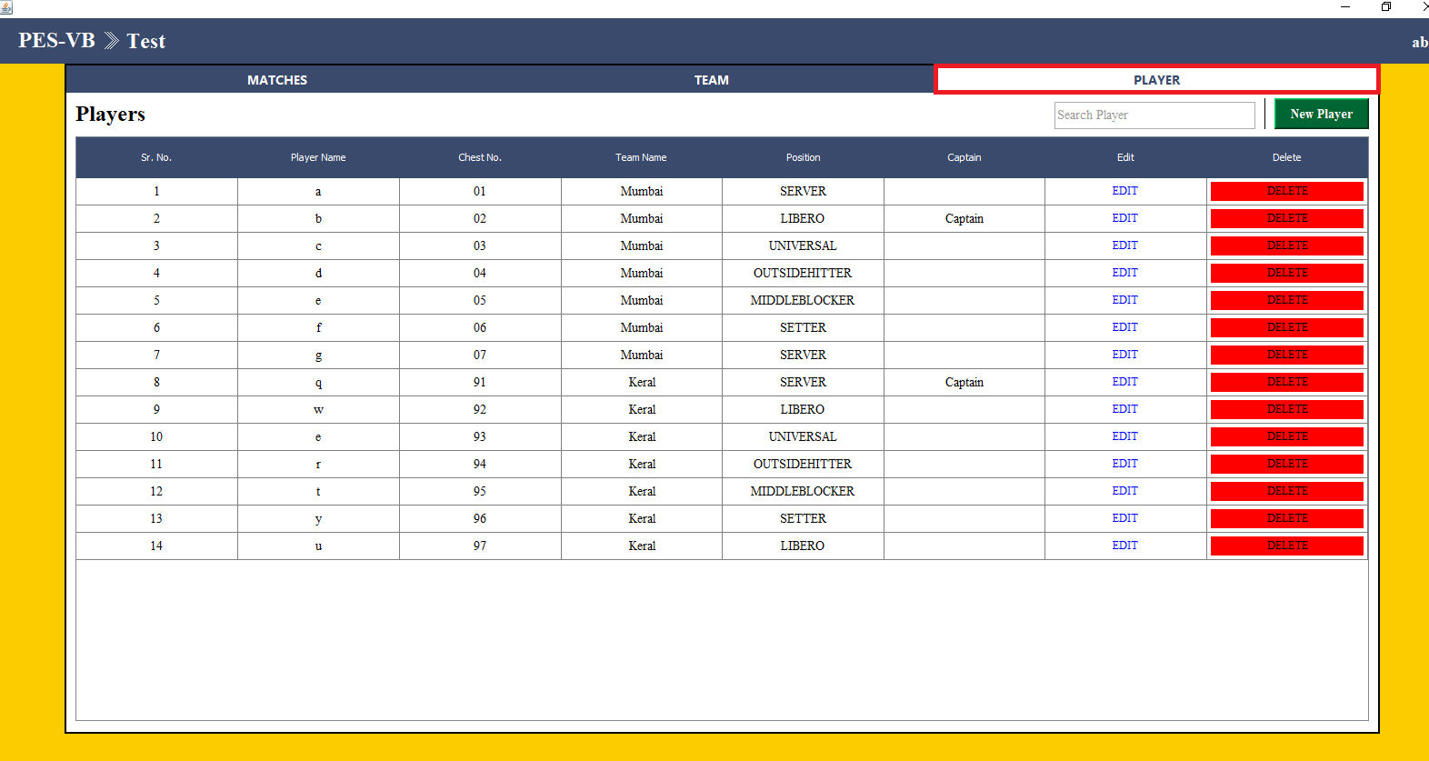

To add new Player in team click new Player and select team to which want to add fill details

And click save to reflect

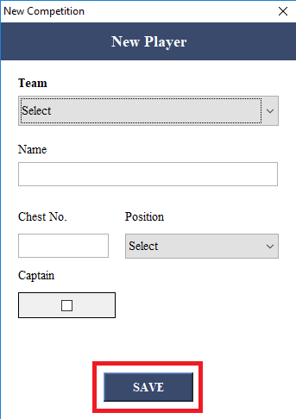

To edit player details click edit do changes and then save

TO view Report

Home >view>match >report

To view report team wise click on team tab and for datasheet click on datasheet tab

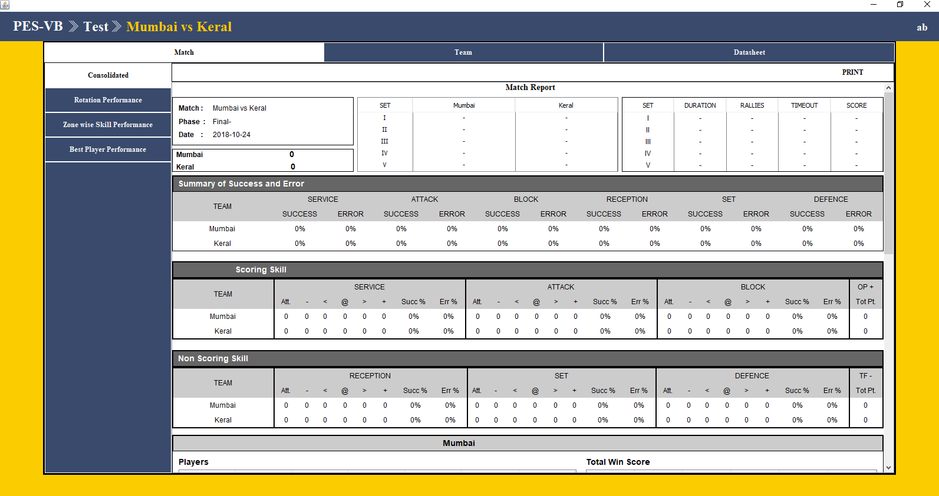

To evaluate

Home >> match >> live

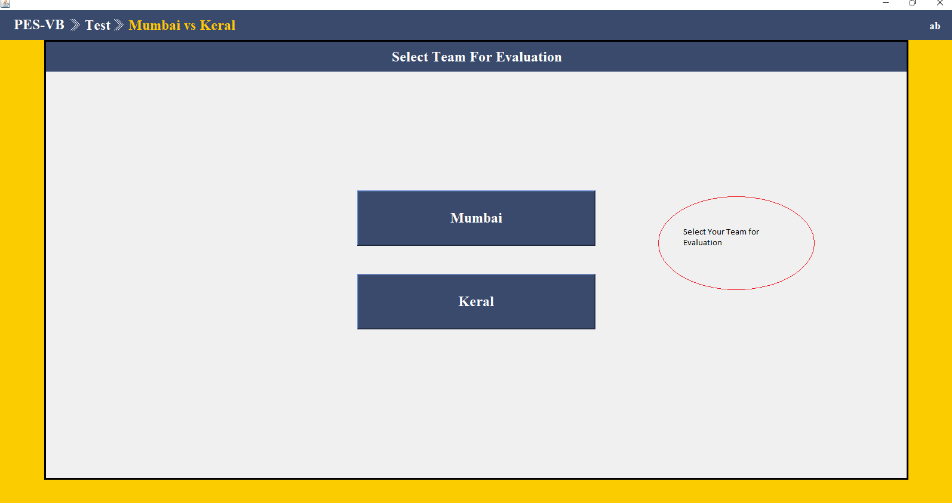

Select your team(Home Team) for evaluation click on you team select set by clicking on set number

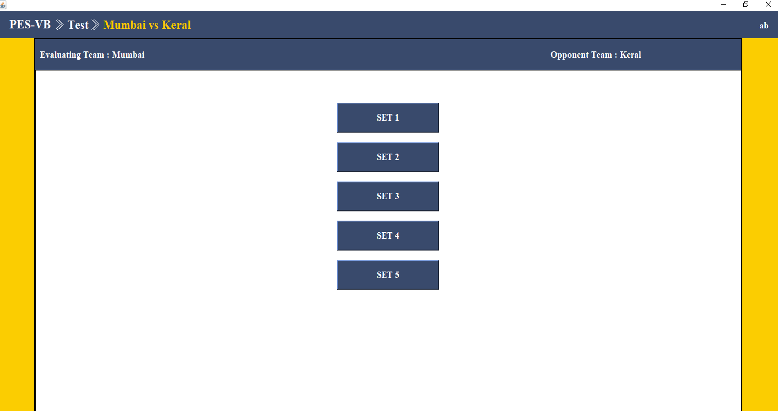

Then set rotation order of player by clicking on player name and setting one libero click save to set

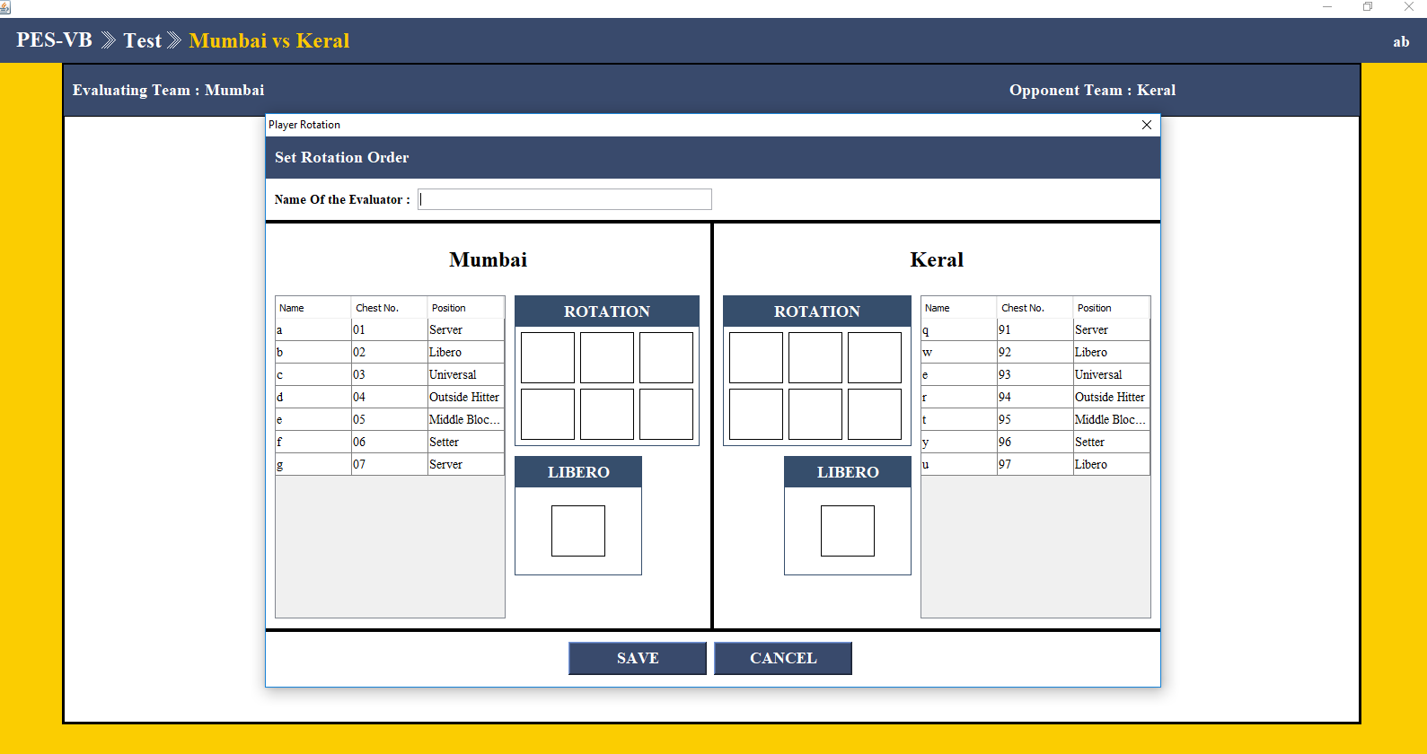

Click ok once saved wait till window as shown below appear

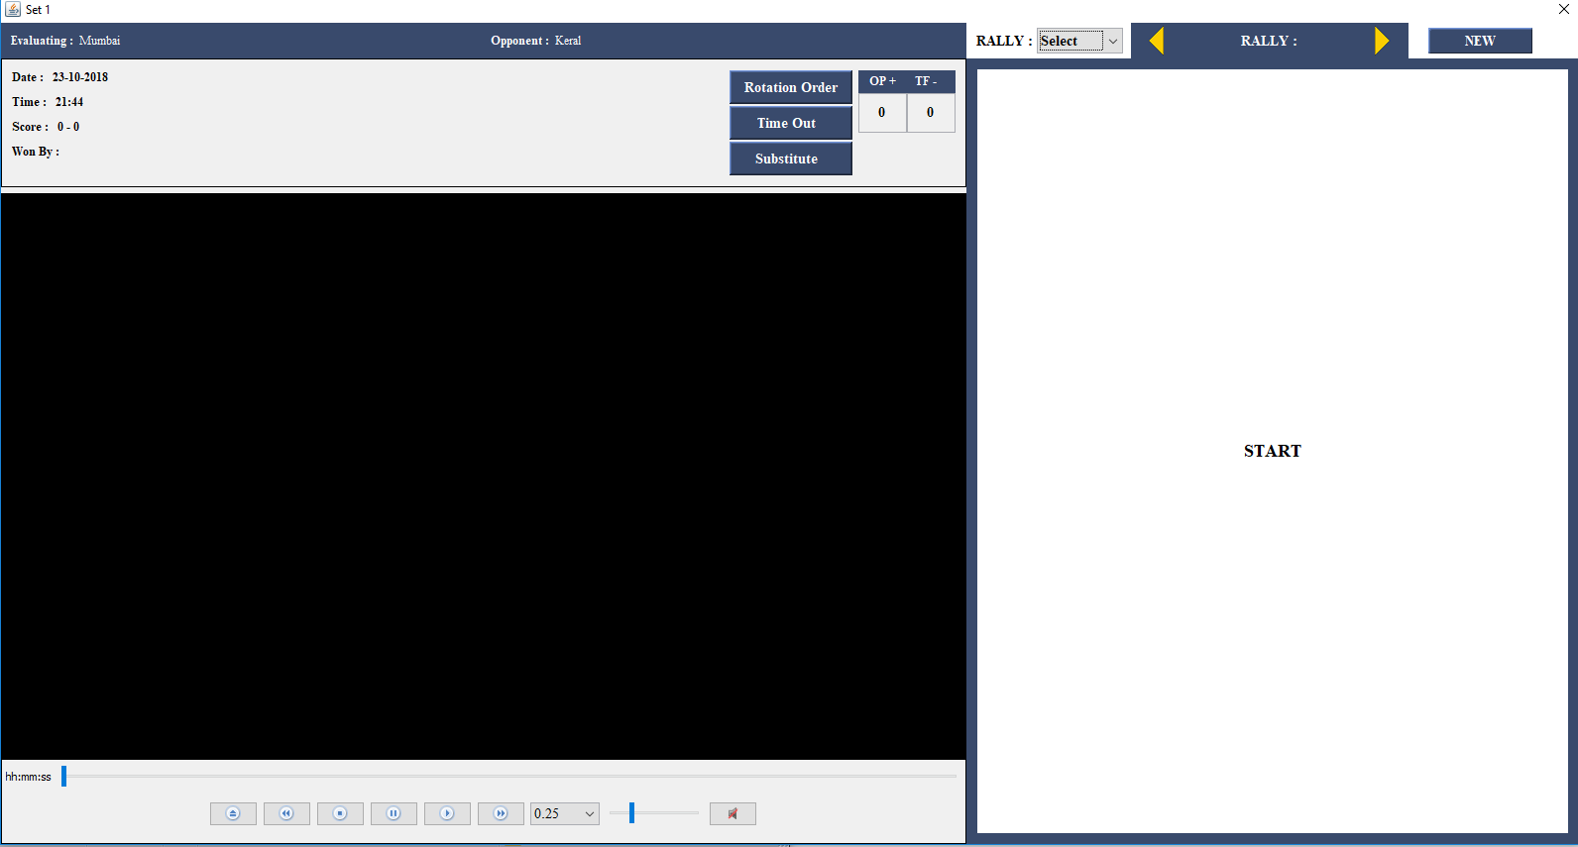

Click on start to evaluate

Change player timeout,rotation order,substitution by click on it

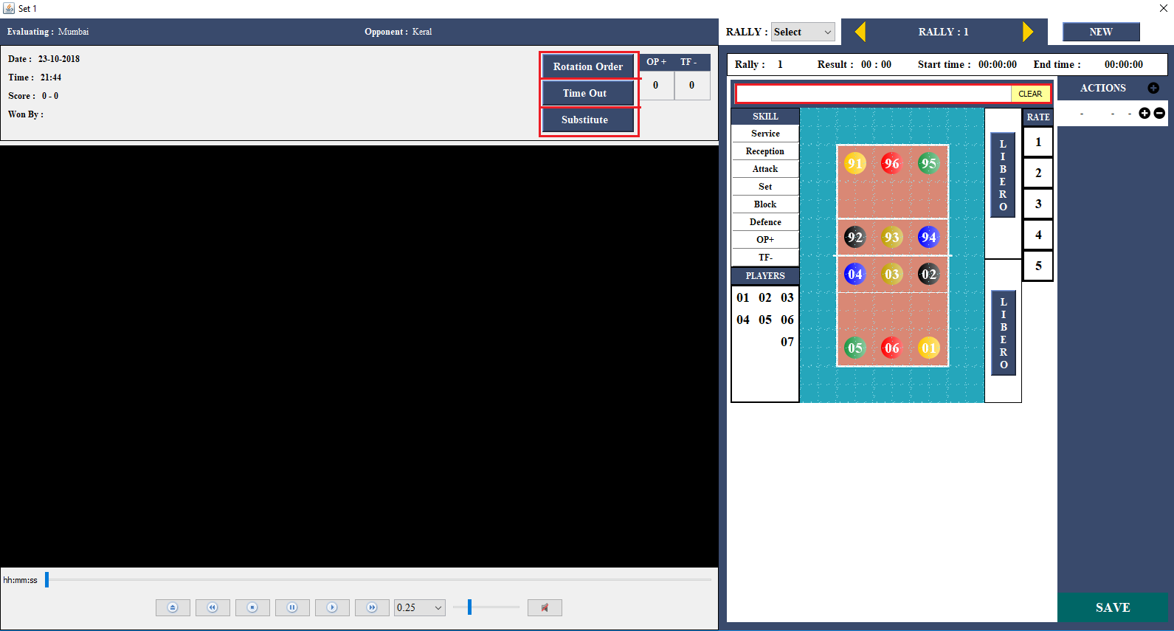

Set rally details according to teams performance

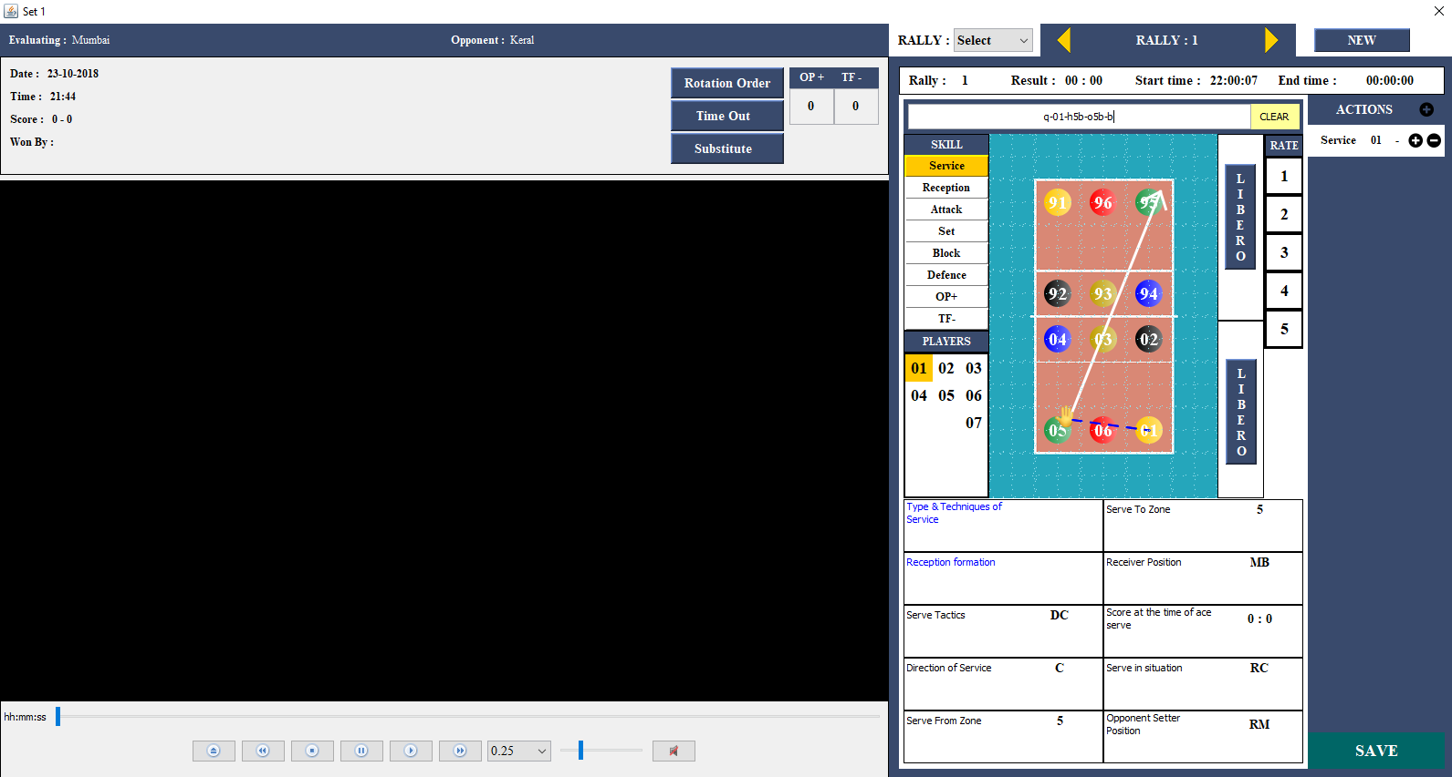

To update Rally details select rally to which want to update

And click update

To substitute player click on substitute

Window appear as shown

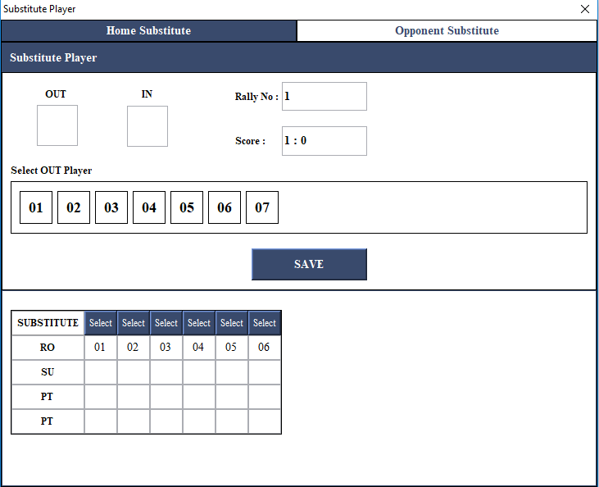

Click on chest number to set out and in for particular rally

To edit substitution click on select

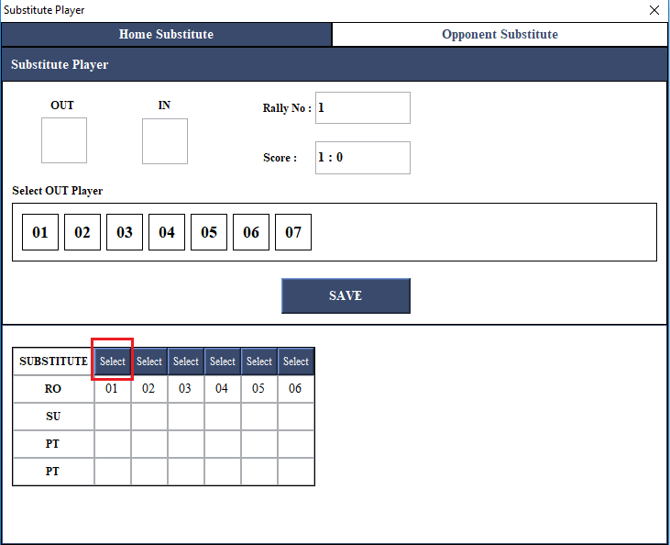

Set substitution point and score

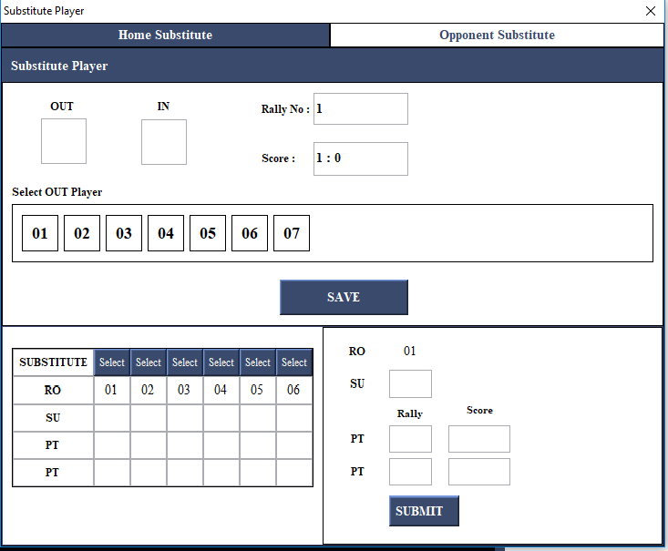

Click submit to save changes

To changes control settings click on user name

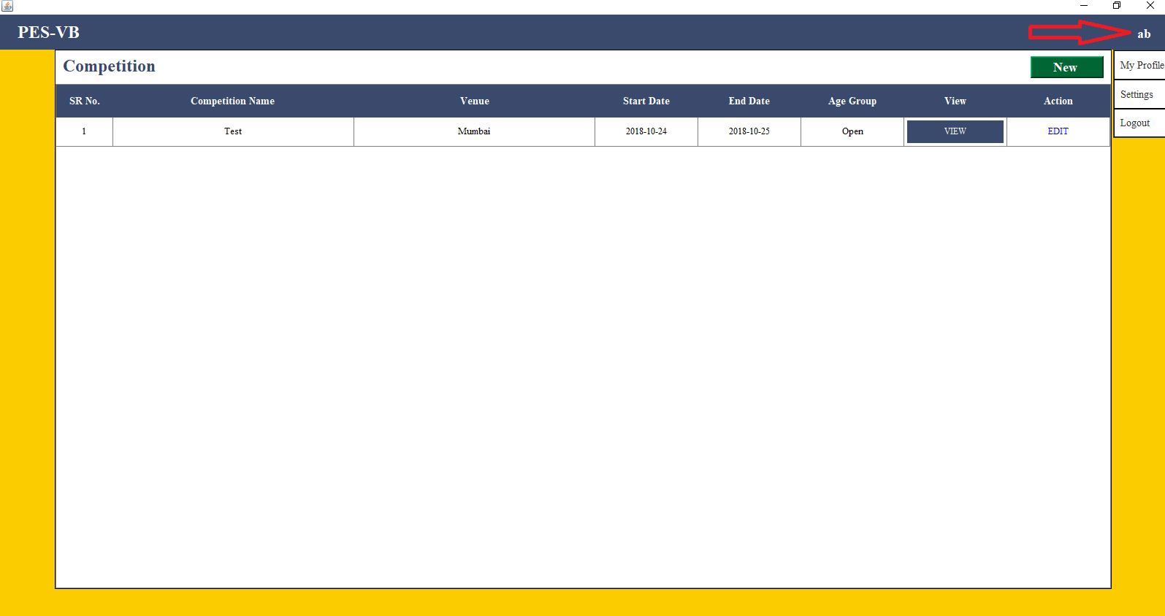

Then settings do setting for with unique keys

To edit profile info click profile then edit and save

.

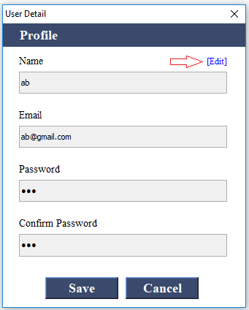

Exit Application by clicking on logout